Response to a brute-force attack
Contents
Configuring wazuh Active response capabilities 1
Attack simulation 3
Visualization of alerts 4
References 4

Machines Used:
- Ubuntu with wazuh installed (Server)
- Ubuntu with wazuh agent installed (Client)
- Kali linux (Attacker)

Configuring wazuh Active response capabilities
We are configuring wazuh to drop the brute force requests and block the requests for a certain period.
- Login to wazuh dashboard.
- Click on menu -> server management -> settings.
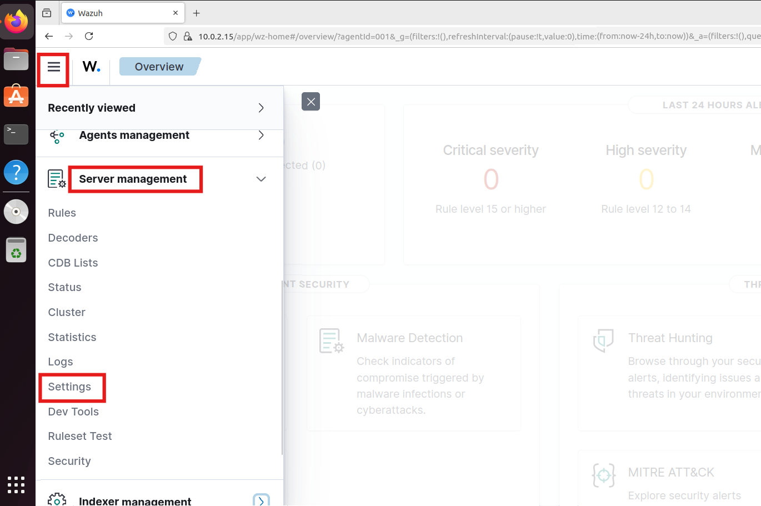
- Click on edit configuration.
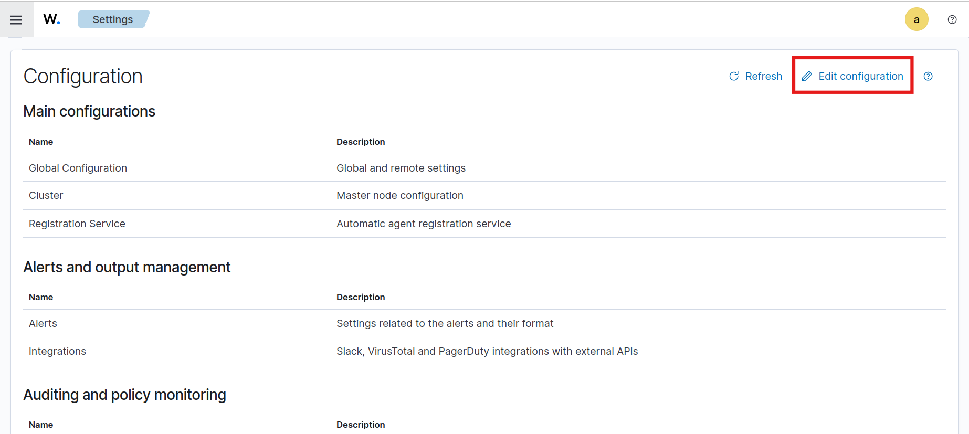

- In the manager configuration look for this block
<!--
<active-response>
active-response options here
</active-response>
-->

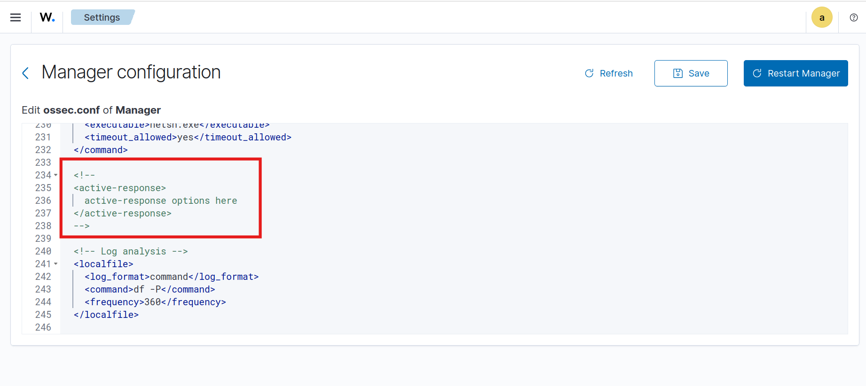
- Add this under the above block to configure the active response.
<active-response>
<command>firewall-drop</command>
<location>local</location>
<rules_id>5710</rules_id>
<timeout>600</timeout> <!-- Block IP for 10 minutes -->
</active-response>
Rule id 5710: Attempt to login using a non-existent user
- Click Save and Restart manager.
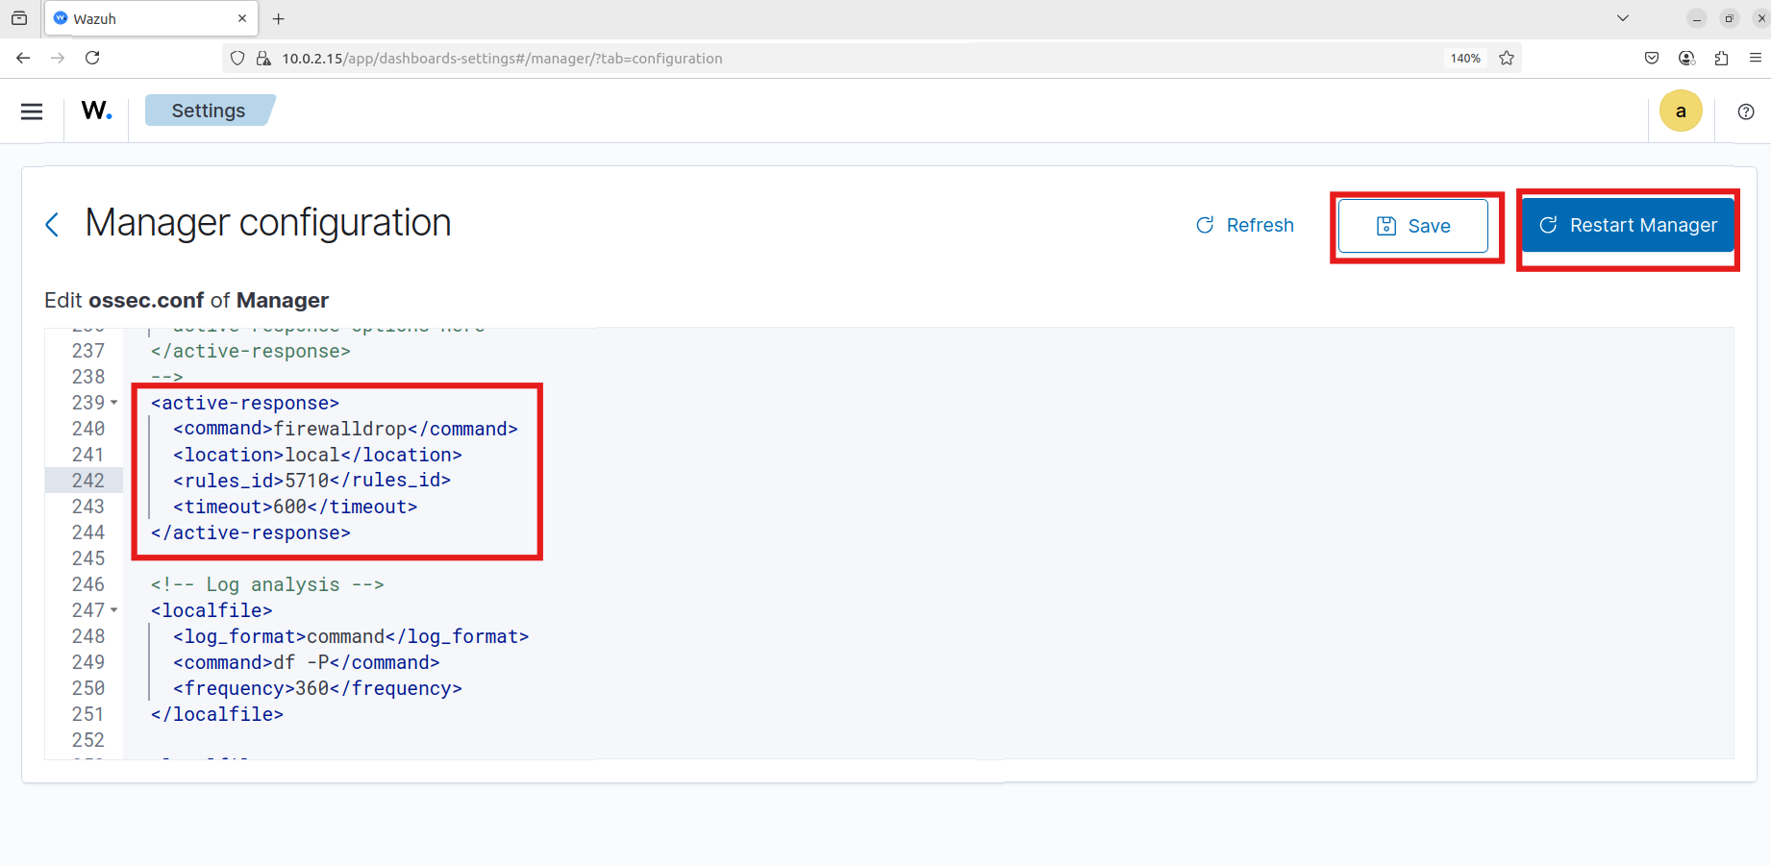

Attack simulation
- Start the kali machine for attacking.
- Download or create common usernames and passwords files. Add username and password of the client machine in the respective files.
- Run the following command to start the attack.
sudo hydra -L <USER_LIST.txt> -P <PASSWD_LIST.txt> <IP> ssh
The following image shows the usenames and passwords and successful ssh brute force attack.
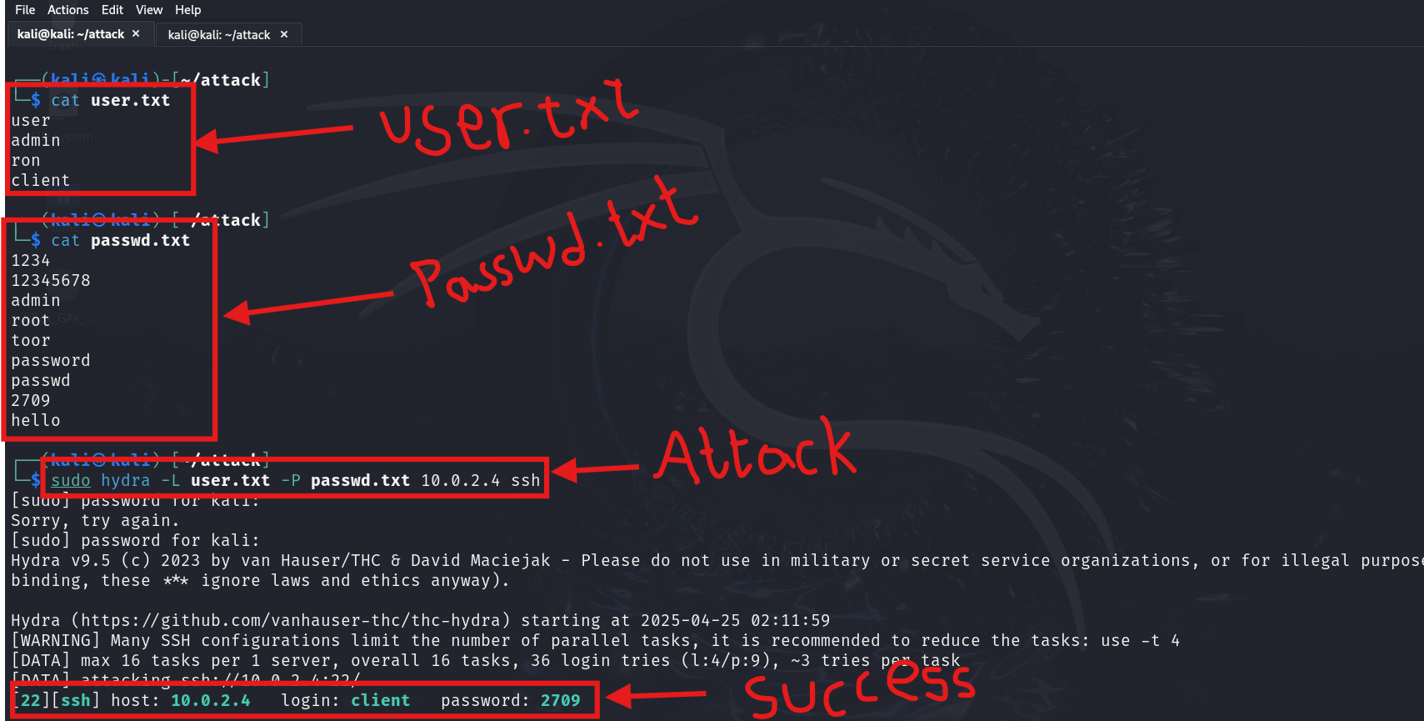
- Now if you try to login using ssh you cannot be able access for 10 minutes.

Visualization of alerts
To visualize the alerts in wazuh dashboard go to Threat Hunting and following alerts are generated.

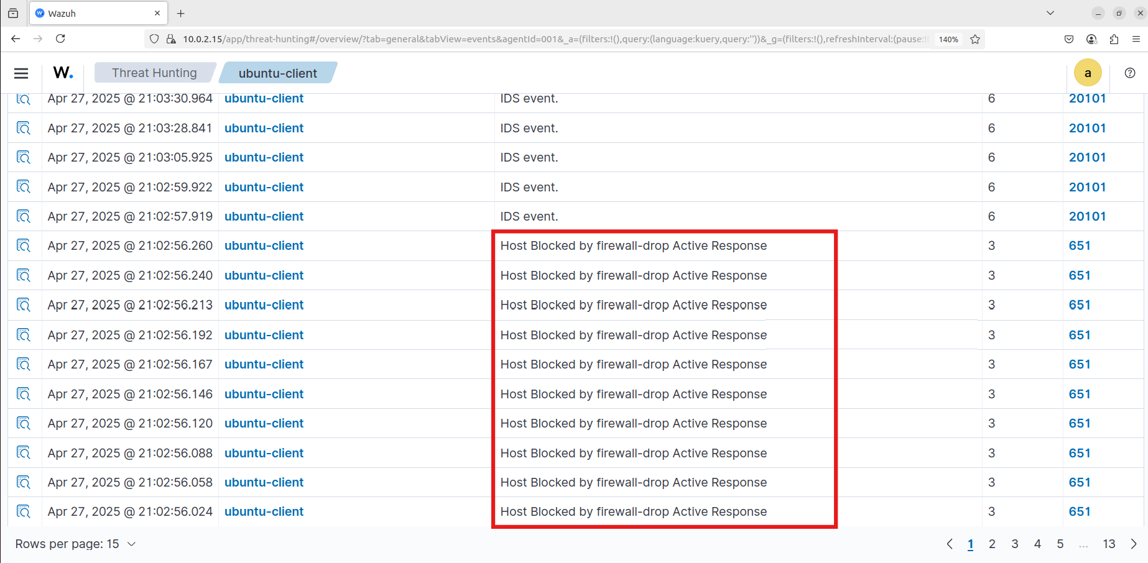

References
- https://documentation.wazuh.com/current/user-manual/capabilities/active-response/index.html

